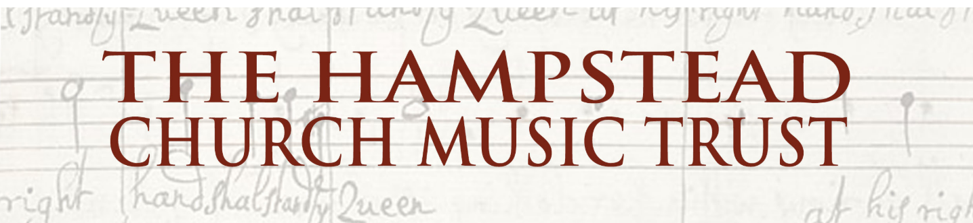

Grant report form

The Hampstead Church Music Trust would ask for a short report by recipients of grants from the Trust. This is helpful not only to ensure that the funds are spent as anticipated, and in accordance with the objectives of the Trust, but also to record any experience and suggestions that help us in allocating grants in the future. Please attach any poster, brochure or programme notes (and we would request that these contain a link to the HCMT website), as well as any photos that we might use on our website or on social media. Thank you!

Date of report:

Report by (name, grant recipient):

Event title:

Event date and location:

Estimated budget:

Grant amount requested (or underwritten):

Grant amount received (or claimed):

Ticket income (if any):

Other income for event (if any, amount and source):

Shortfall / surplus (amount and, in the case of a surplus, destination, e.g. to be applied to a future request or to an agreed charity or to be returned):

Audience attendance:

Short report [e.g., programme, musicians, whether the objectives were met, audience feedback, highlights, difficulties experienced, any useful observations or suggestions for future events]. We would appreciate it if this could include a few sentences suitable to be published on our website:

